Computer Science and Engineering Department
Motilal Nehru National Institute of Technology Allahabad
MCA-1st Semester Session 2021-22
Programming and Problem Solving Lab (CS 31201)
Week 1– Assignment(Solution)

Name: Mohd Monish
Reg No. : 2021CA063
Submission Date: 23 October 2021

1. pwd
DESCRIPTION
Print the full filename of the current working directory.

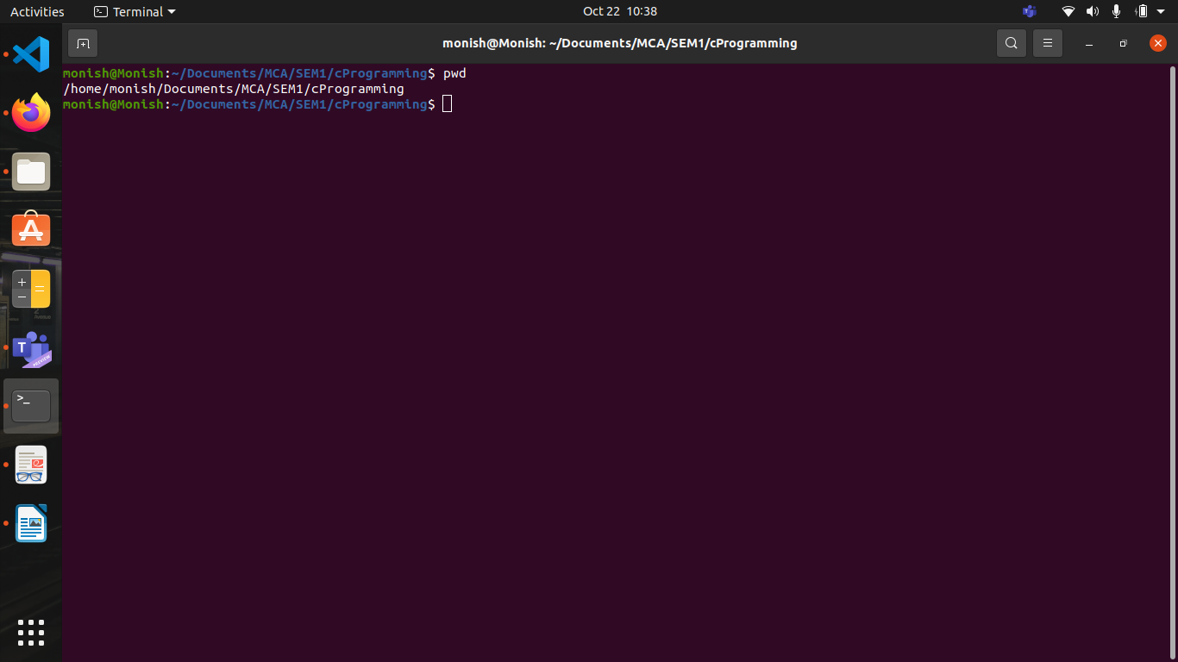

2.ls
DESCRIPTION
List information about the FILEs (the current directory by default). Sort entries alphabetically if none of -cftuvSUX nor –sor is specified.

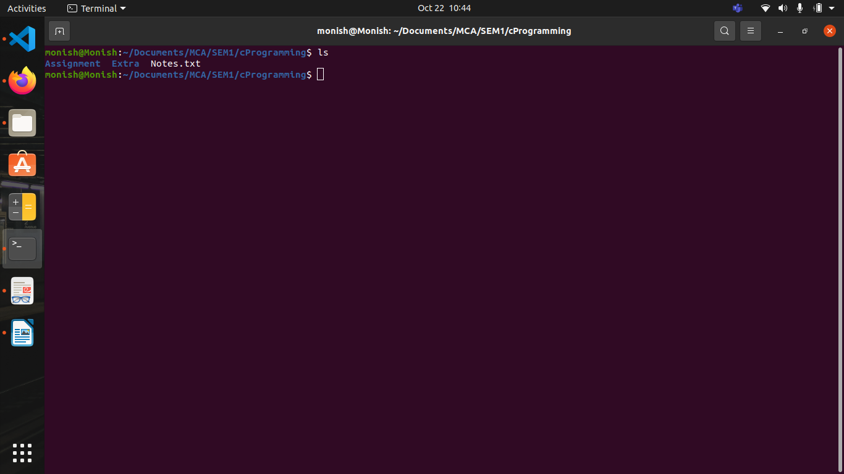

3.ls –a
DESCRIPTION
List information about the FILEs (the current directory by default)., does not ignore entries starting with .

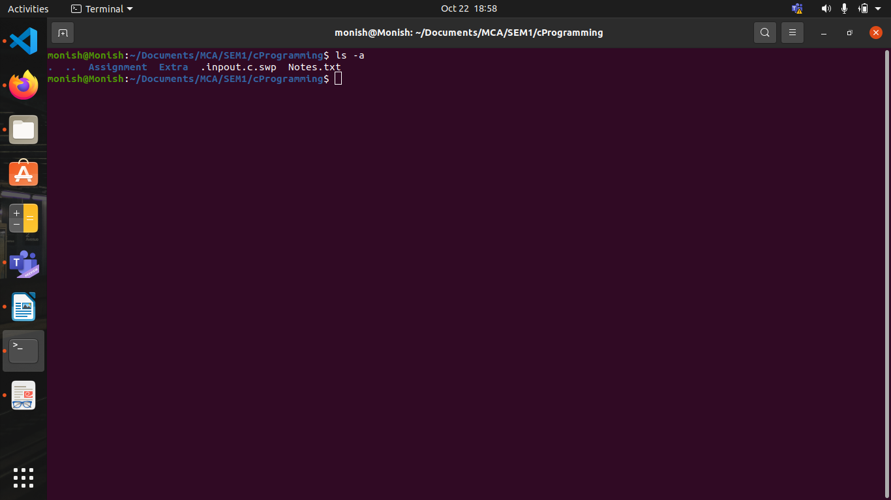

4.mkdir
DESCRIPTION
Create the DIRECTORY(ies), if they do not already exist.

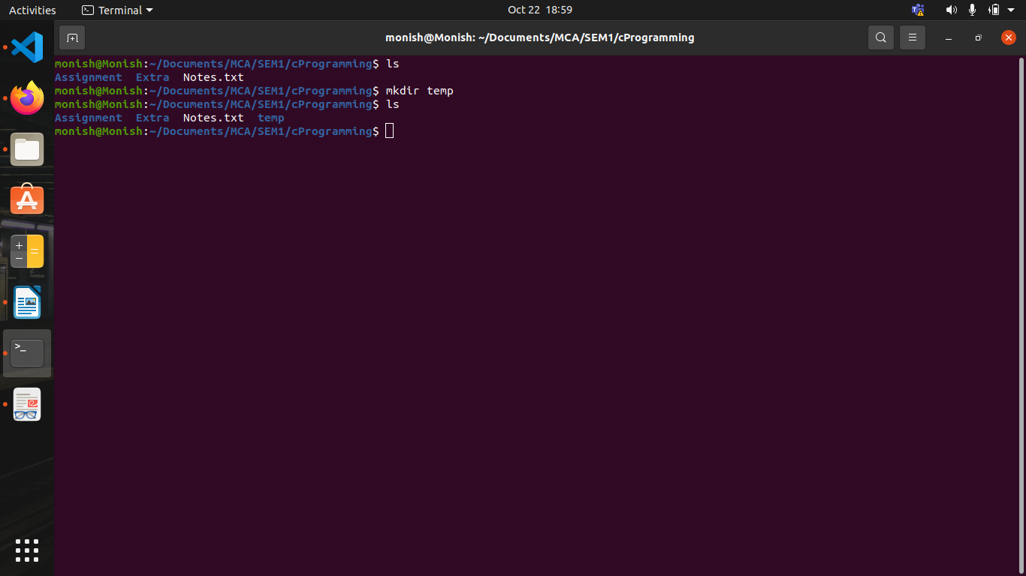
5.rmdir

DESCRIPTION
Remove the DIRECTORY(ies), if they are empty.

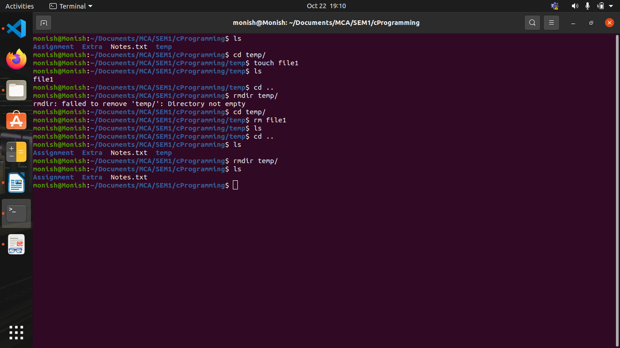

6.rm -r

DESCRIPTION
remove directories and their contents recursively.

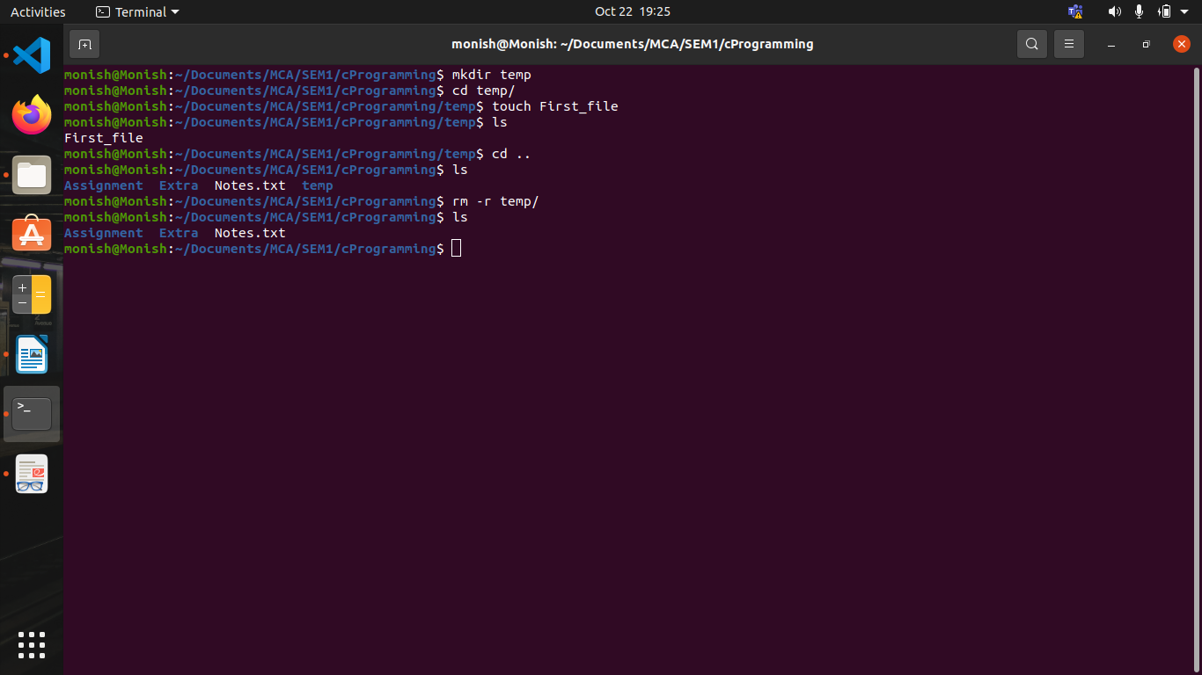
7. cd
this command also work same as cd ~ command.

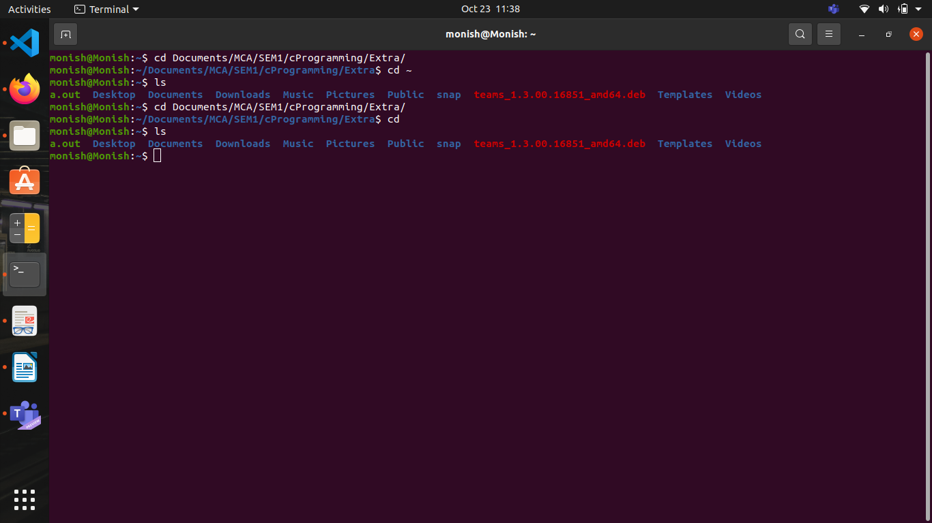

8. cd..
this command is used to move to the parent directory of current directory, or the directory one level up from the current directory. “..” represents parent directory.

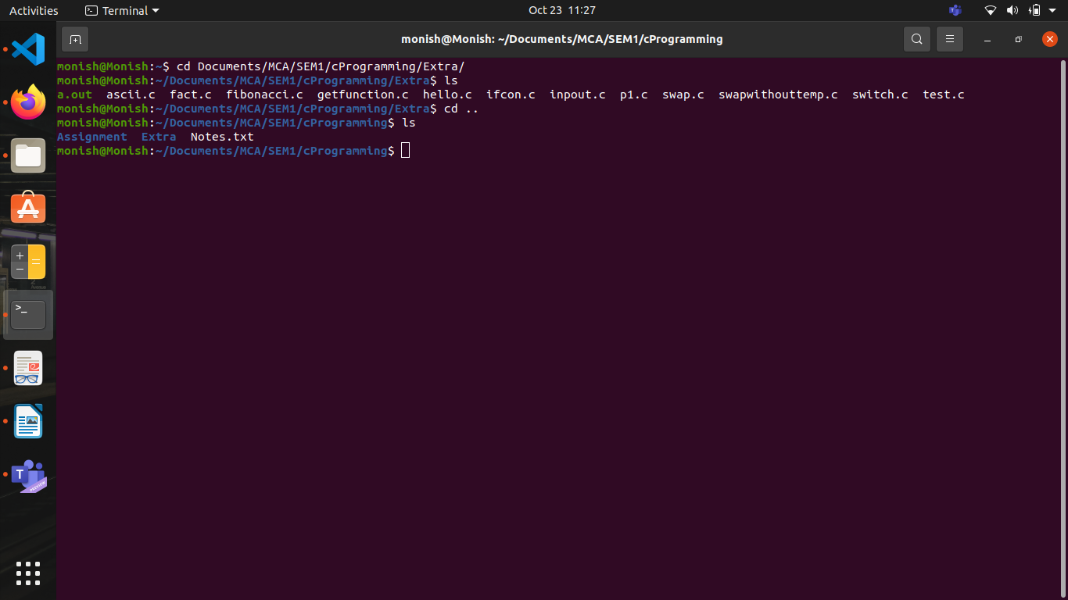

9.cd~

DESCRIPTION
this command is used to change directory to the home directory.

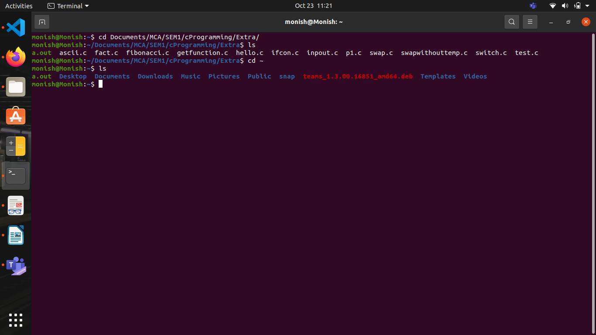
10.ls -l
DESCRIPTION
The UNIX ls -l command can provide you with detailed information about each file and subdirectory in the current folder.

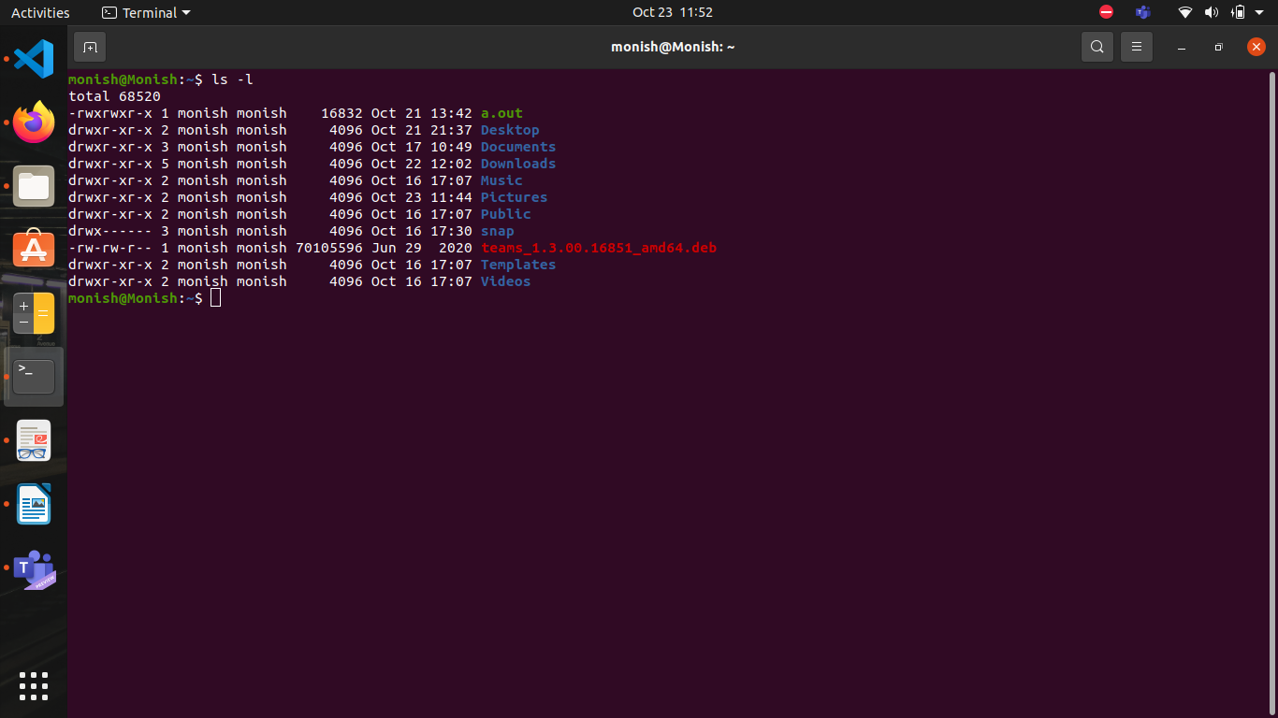

11.clear
DESCRIPTION
clear clears your screen if this is possible, including its scrollback buffer (if the extended “E3” capability is defined). clear
looks in the environment for the terminal type given by the environment variable TERM, and then in the terminfo database to determine how to clear the screen.
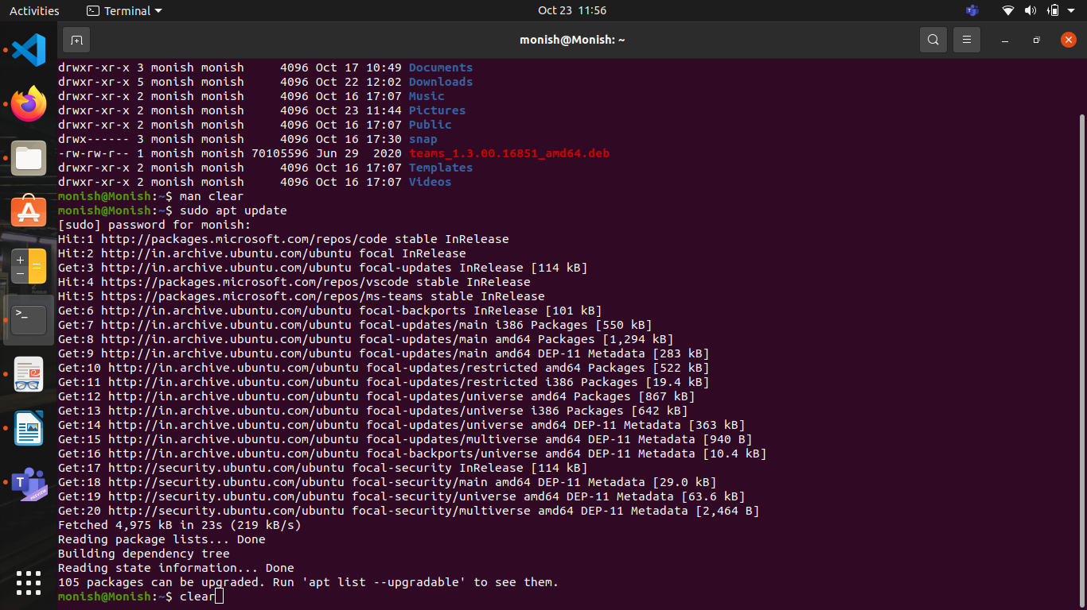
When we press enter then got clear screen

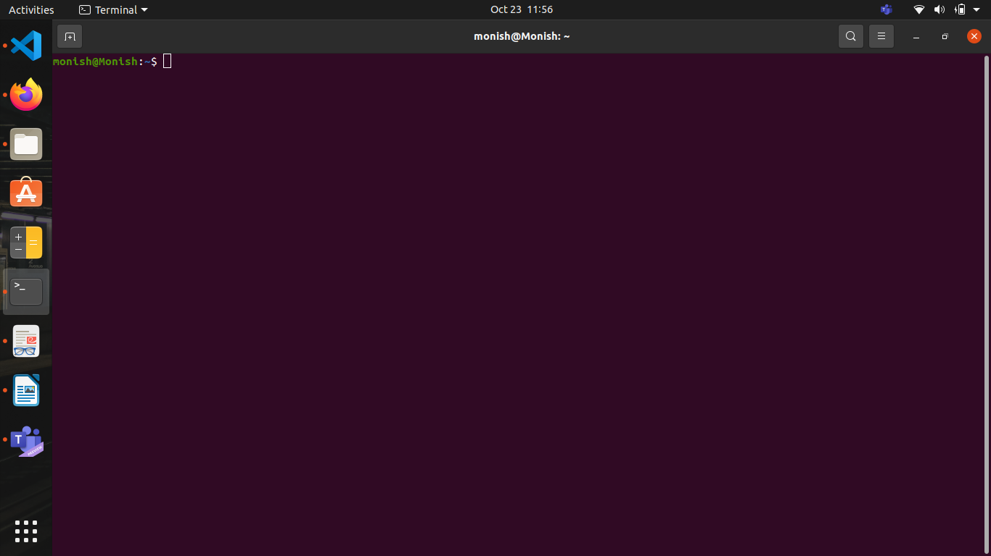

12.cat
DESCRIPTION
Cat(concatenate) command is very frequently used in Linux. It reads data from the file and gives their content as output. It helps us to create, view, concatenate files
12.1 cat filename
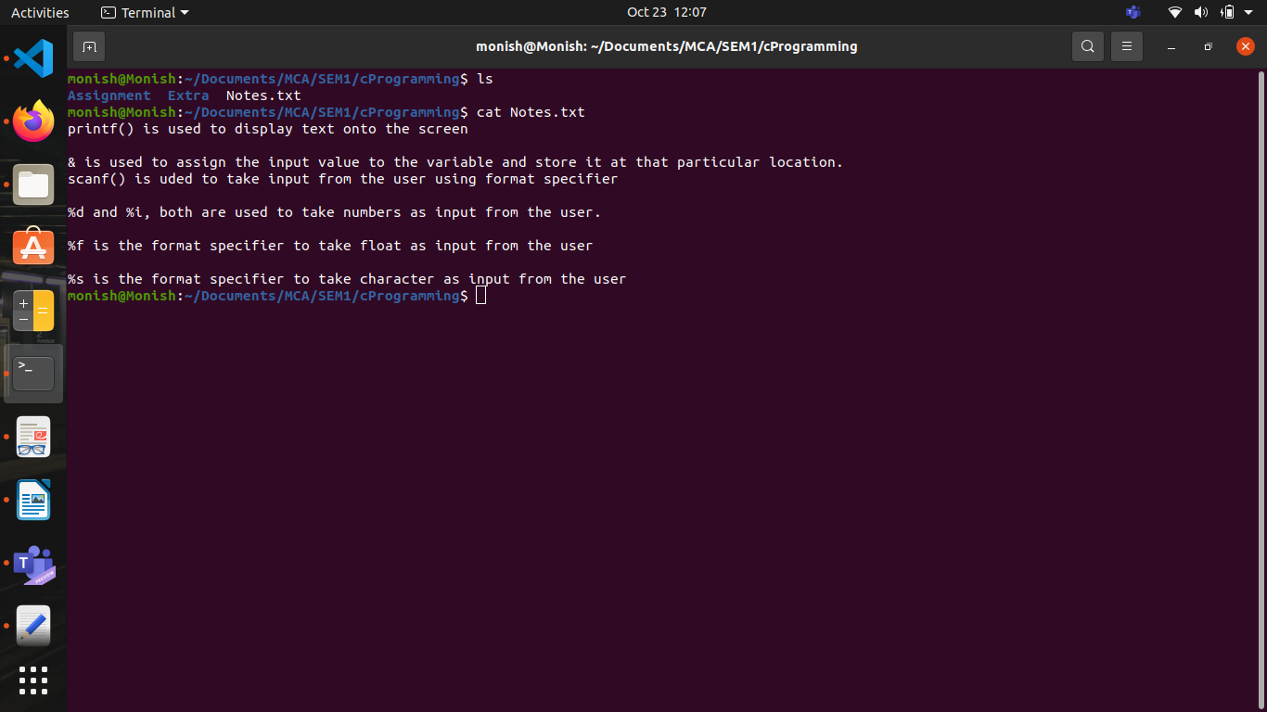
12.2 cat -n filename

To view contents of a file preceding with line numbers.
Command
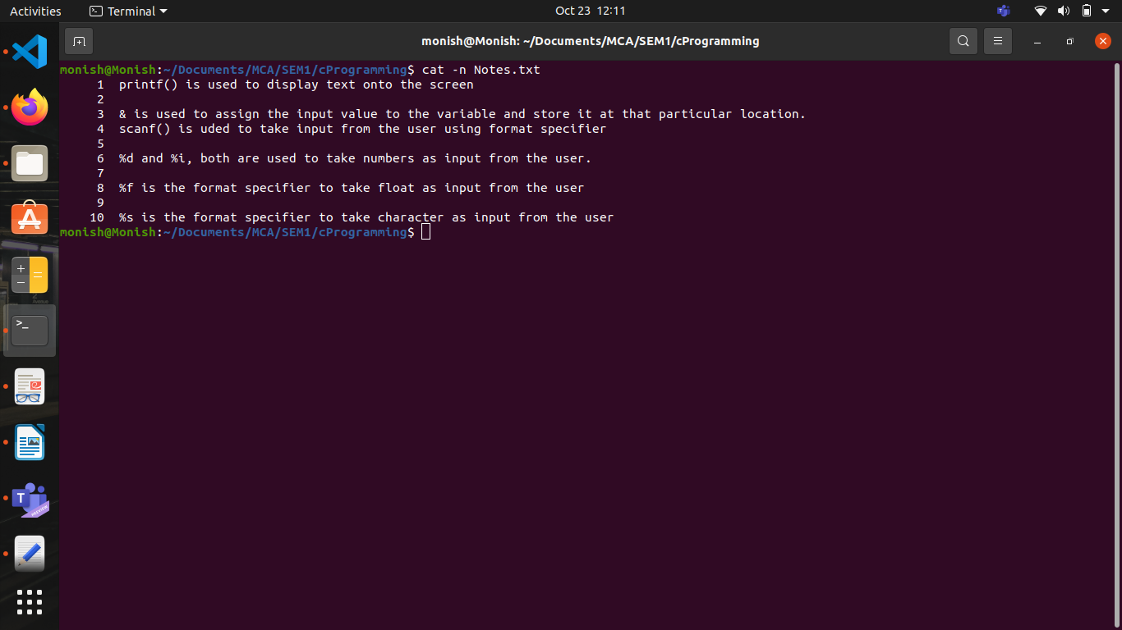

12.3 cat >newfile
Will create and a file named newfile

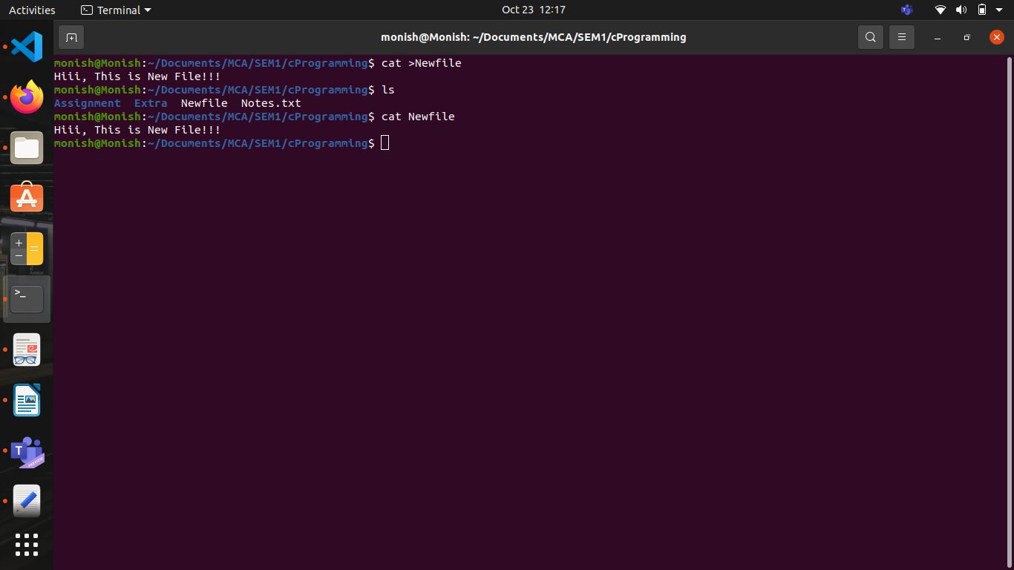

13.whoami
DESCRIPTION
Print the user name associated with the current effective user ID. Same as id -un.

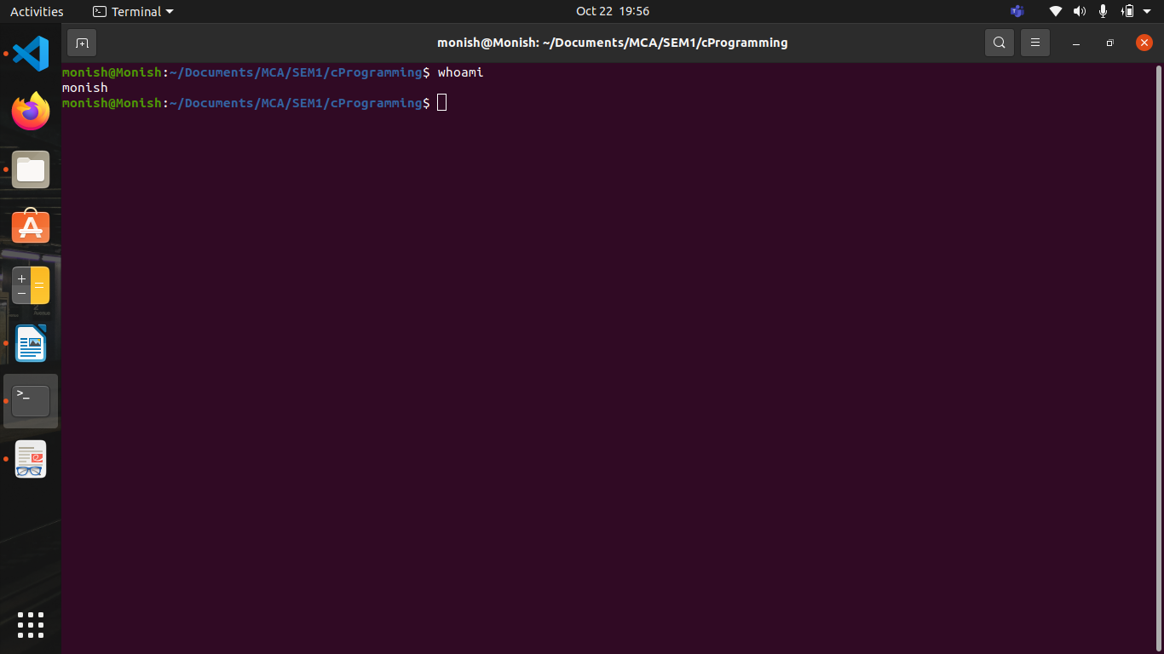

14.mv
DESCRIPTION
Rename SOURCE to DEST, or move SOURCE(s) to DIRECTORY.
mv stands for move. mv is used to move one or more files or directories from one place to another in a file system like UNIX. It has two distinct functions:
(i) It renames a file or folder.
If the destination file doesn’t exist, it will be created. In the above command mv simply replaces the source filename in the directory with the destination filename(new name)

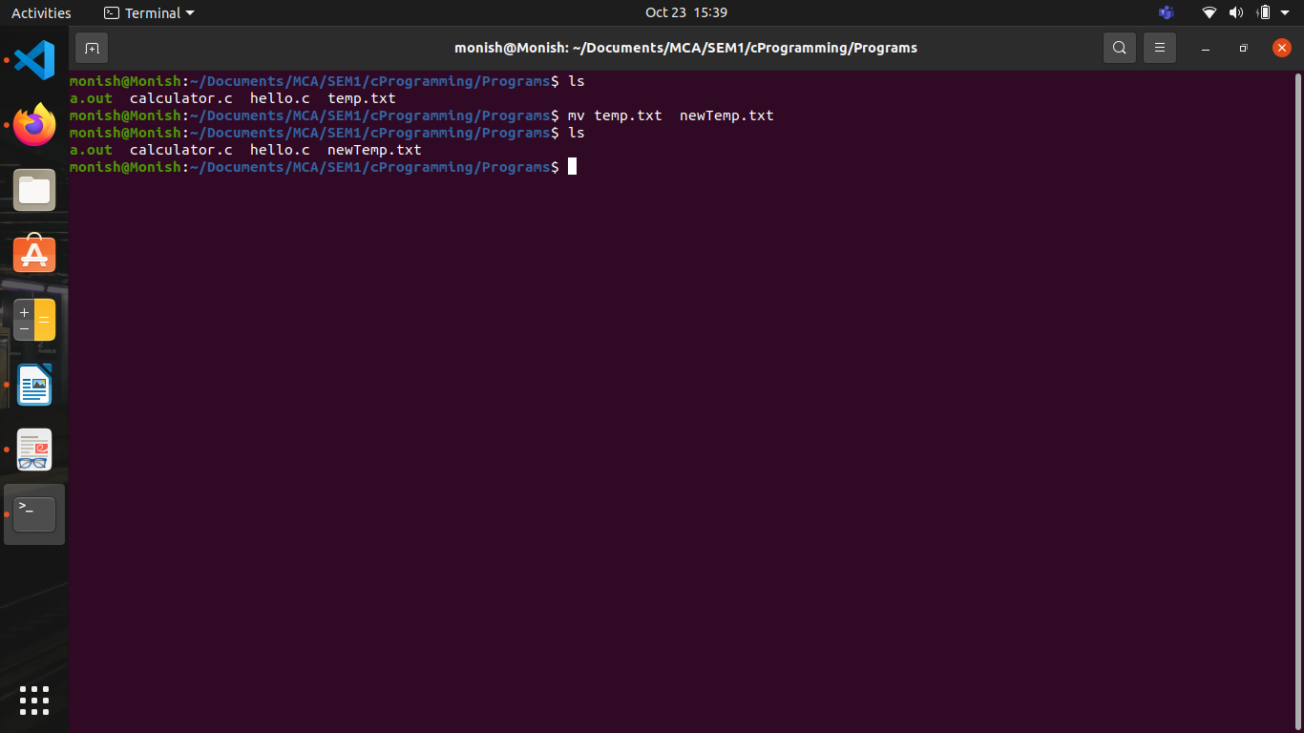
(ii) It moves a group of files to a different directory.
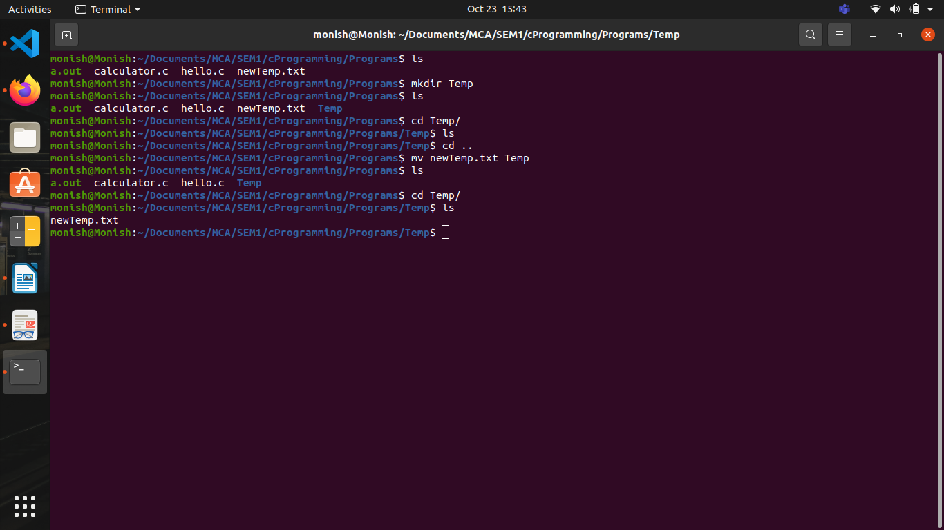

15.echo
DESCRIPTION
Echo the STRING(s) to standard output or display a line of text.

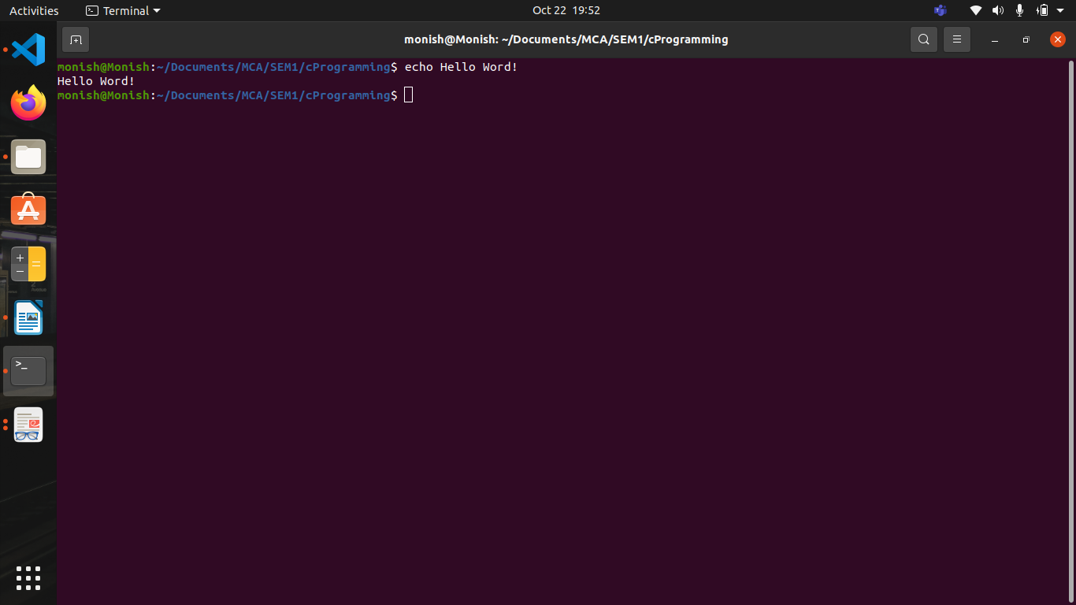

Program 1

Here we crate a c file hello.c

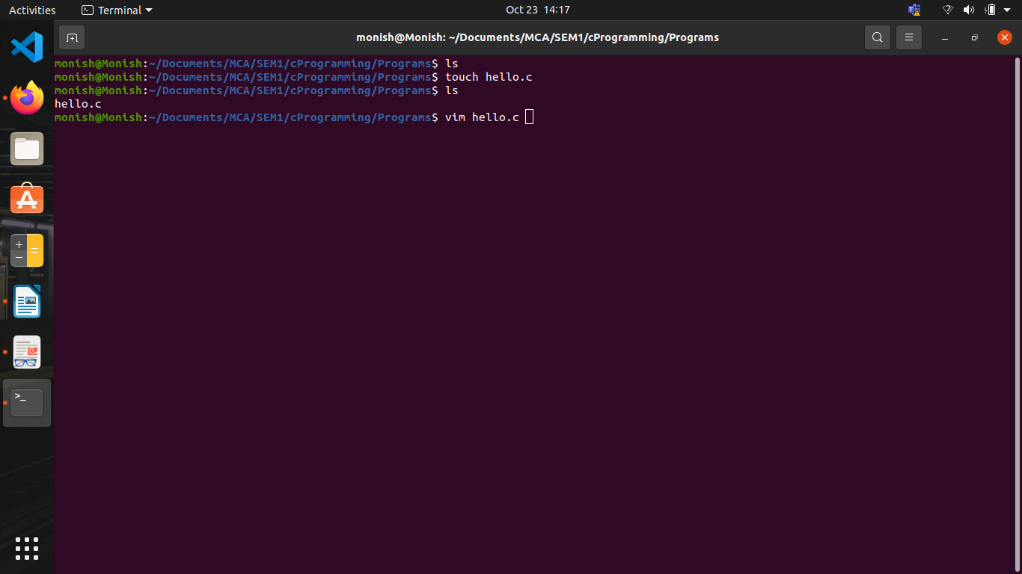

CODE SECTION

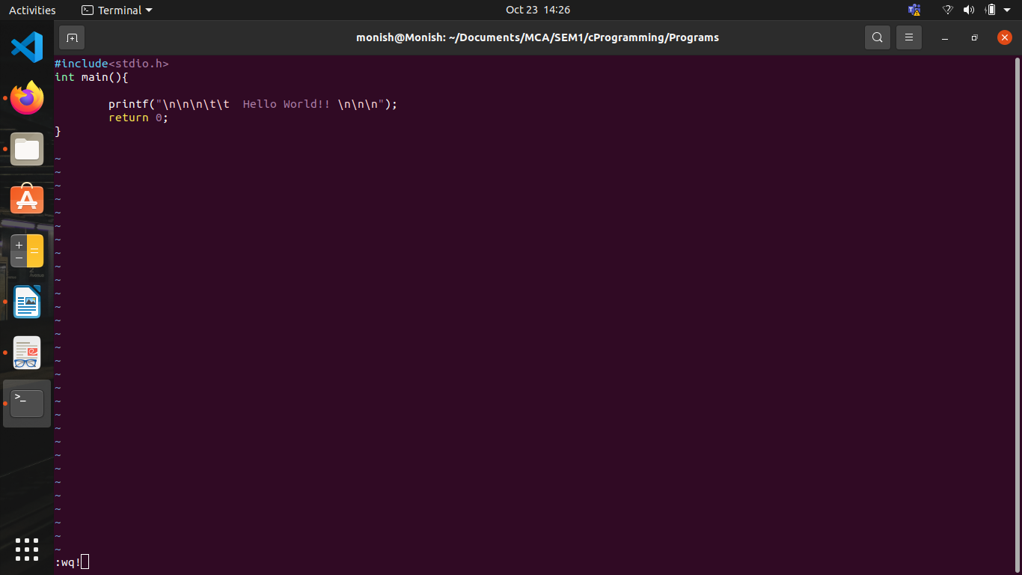

OUT PUT SECTION

